**"Enhancing Personal Effectiveness: A Strategic Path to Becoming a Project Manager in the Technology Industry"**

**Student Name:**

**Student ID:**

**Word Count:**

Table of Contents

Introduction 3

Task 1: Reflection on Skill Set about Career Goal 4

Reflective Practice Model: 4

Task 2: Assessment of Habits and Behaviors Impacting Career 7

Covey Self-Assessment Questionnaire: 7

Task 3: Development of a Short-Term Plan for Improvement 9

Identification of Areas for Improvement 9

Development of a Short-Term Plan: 9

Conclusion 11

References: 12

# Introduction

**Introduction to Personal Effectiveness:** Personal effectiveness is an important element of personnel management which implies knowledge, behaviors and approach helping individuals increase efficiency within their work and private lives. To those who promote the framework, it is a process of self-improvement, education and the act of adapting to new tools and procedures for improvement of an individual’s performance and productivity as postulated by Covey (1989). Defining from the idea that personal capacitance can be enhanced to the extent of adding value to career activities to get the optimum result, the concept can be defined as (Goleman, 1995).

**Career Goal:** The career goal chosen is to become a Project Manager in the technology industry. This role requires a combination of technical skills, leadership abilities, and strong organizational and communication skills, making it a great fit for analyzing personal effectiveness.

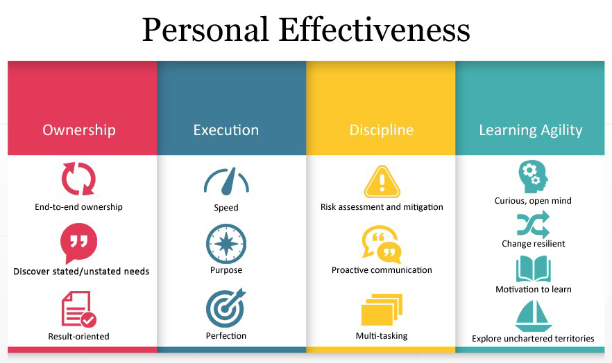

Figure 1 "Personal Effectiveness" chart (Claessens et al., 2007).

The "Personal Effectiveness" chart outlines four essential areas for success: There is the ownership, execution, discipline, and learning agility. Ownership involves assuming accountability for tasks, what is said, and left unsaid, and acting in a way that is productive to arrive at the intended goals. These are velocity, direction, and efficiency in doing a given work together with the flexibility to multitask. Discipline also entails evaluating risks, interacting as a way of avoiding risks, and being able to do several things at the same instance to ensure that tasks are achieved in an orderly manner. Last, Learning Agility means curiosity, the ability to withstand change, fascination with learning, and willingness to undertake complex tasks.

These categories together define a complete model of personal work effectiveness so that people would have ownership over their positions, and perform tasks I-Day, 2009 within their roles with focus, discipline, and adaptability to change or new learning.

For purposes of this report, personal effectiveness is described through three activities. The first assignment comprises a Self-reflective account of a particular piece of work, undertaken at work or university and indicates strengths and weaknesses with the help of Gibbs’ (1988) model of reflection. The second task focuses on a set of questions related to personal habits and behavior Instrument used in this task of the program is the Covey self-assessment questionnaire (Covey 1989). Lastly, the final assignment includes the formulation of a short-term plan using the SMART model to deal with the observed weaknesses and improve personal branding.

# Task 1: Reflection on Skill Set about Career Goal

Reflecting on my experience and skill set has allowed me to understand how these strengths and weaknesses relate directly to my career goal of becoming a Project Manager in the technology industry. Strong communication skills, for example, are essential in ensuring team members understand their roles and responsibilities, which is critical in a project management role where clear, effective communication can make or break a project's success. Similarly, improving time management is vital for a Project Manager in the technology industry, where deadlines are tight and resources need to be managed efficiently to meet project goals.

Reflective Practice Model: Gibbs’ Thinking about Phases of an Experience/Activity is a common model that implies a structured analysis of an Experience/Activity. The model comprises six stages: especially if it is used in professional development contexts, which is why it is called a structured model (Gibbs, 1988). This model assists the professional in reflecting on practice and in making interpretations about practice to gain learning from situations (Boud et al., 1985). This reflection is particularly important as I work towards my career goal of becoming a Project Manager in the technology industry.

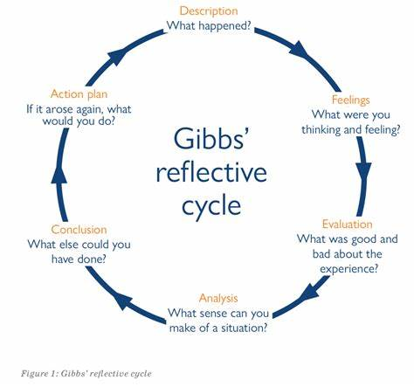

Figure 2 Gibbs' Reflective Cycle (Gibbs, 1988).

During a recent group project at university, I utilized Gibbs' Reflective Cycle to evaluate my performance as a team leader. The project required coordinating with several team members to complete a research assignment under a tight deadline. Initially, I felt confident in my ability to manage the project; however, as challenges related to time management and team dynamics emerged, I had to reassess my approach (Schon, 1983).

**Identification of Skill Set:** Reflecting on this experience, I identified both strengths and weaknesses in my skill set. A key strength was my ability to communicate effectively, which was essential for facilitating discussions and ensuring that team members understood their roles (Brown & Palincsar, 1989). My communication skills were further supported by my capacity for active listening, which helped maintain a collaborative team environment (Covey, 1989). However, a significant weakness I observed was in my time management skills. Despite my best efforts, I struggled to allocate adequate time for each task, resulting in last-minute work and unnecessary stress (Macan, 1994). These skills are crucial for my future role as a Project Manager, where effective communication, leadership, and time management are vital.

Moreover, while I demonstrated strong problem-solving skills, my delegation was suboptimal. I found myself taking on too many responsibilities, which prevented me from focusing on high-priority tasks and hindered the development of my team members’ skills (Yukl & Mahsud, 2010). These insights highlight the need for improvement in these areas to enhance both my effectiveness and that of the team.

**Analysis of Skills about Career:** Through this reflection, I have been able to learn some skills relevant to my preferred career path in project management. While, communication and conflict-solving are essential components of project management because one has to be able to explain project goals and overcome any dispute that may arise in the course of project delivery (Turner & Müller, 2005). Intuitively, my skills in these respects correspond to the time requirements of a project manager’s position, I can thus prove that I am suited for this kind of job. Understanding these skills and areas for improvement is essential for my development as a Project Manager in the technology industry.

However, the weaknesses that I highlighted, particularly the ones in the areas of time management and delegation, present some setbacks in the realization of career objectives. In a project, time is also very important and what may take a shorter time may take another longer period thus leading to more expenses and time costs (Kerzner & Günd newItem window: 2017). Likely, the same generals understand that delegation plays the same role in workload distribution and team building, which are vital for the project’s success (Häusser et al., 2011). Lack of delegation skills compels me to be overly engrossed in all tasks and this may slow down my promotion or career advancement in my line of work.

To counter these areas of weakness, I will make arrangements to improve my time management skills and techniques since they are part of my weaknesses; I will categorize my tasks depending on their importance and use tools such as the Gantt chart in fixing my working schedule (Claessens et al., 2007). Furthermore, I have plans to enhance my delegation skills, that is, getting to a situation whereby I am capable of assigning tasks to the members and also guiding them through those tasks (Hackman & Wageman, 2005). These improvements are relevant to my progress in the position of a project manager and therefore important to my career work.

**Conclusion:** Consequently, reflective practice has been used in finding out my strengths and weaknesses. Using Gibbs’ Reflective Cycle helps me understand how the skills I possess can help me pursue a career in project management. Hence, by emphasizing an increase in time utilization and delegation, One Plus is bound to be more efficient and likely to attain career objectives.

# Task 2: Assessment of Habits and Behaviors Impacting Career

Covey Self-Assessment Questionnaire: Understanding my habits and behaviors, particularly in terms of how they impact my ability to manage time and prioritize tasks, is crucial for my development as a Project Manager in the technology industry. The ability to manage projects efficiently, handle stress, and prioritize tasks in a fast-paced environment are key to success in this role. By addressing these areas, I can better prepare myself to lead projects effectively, ensuring that deadlines are met, and project goals are achieved.

The assessment is directly relevant to my career goal of becoming a Project Manager, where managing habits and behaviors effectively is key to success.

The Covey Self-Assessment Questionnaire is a measure intended for protecting and defining the subjects’ habits regarding effectiveness within the private as well as work contexts. These include proactive, time management, and prioritizing which are essential when pursuing different careers (Covey, 1989). Having done the self-assessment, I was able to identify some strong features and vices in my set behaviors that affect my career advancement.

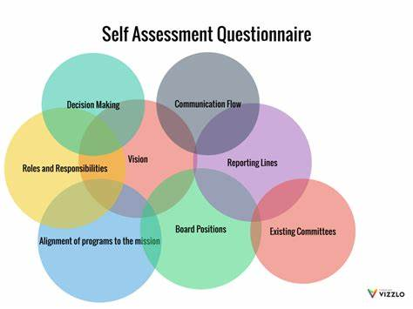

**Figure 3 Covey Self-Assessment Questionnaire**

**Strengths and Weaknesses Identification:** One of the potential assets discovered in the course of the questionnaire is that I am very likely to initiate tasks. Proactivity implies a proactive personality which casts the individual as accountable for his/her behavior and also the focus on solutions which is a key attribute that is desirable in marketspace (Crant, 2000). For example, in one of the recent projects, I took proactive to deal with possible risks right from the start hence completing the project ahead of time. This behavior corresponds with available literature evidencing that people displaying proactive behaviors are in a better position to achieve in volatile career settings (Parker, Bindl, & Strauss, 2010). Recognizing these strengths and weaknesses is crucial as they directly impact my ability to manage projects in the technology industry.

However, the assessment also highlighted a significant weakness: A bad habit of the author – a tendency to procrastinate and difficulty in the organization of work, including in cases when different tasks have to be performed in parallel. On this premise, the temporal nature of time is associated with stress levels and efficient and efficient allocation of tasks (Claessens et al., 2007). An example of this was when I was undertaking several activities at the same time, resulting in several late completes and huge pressure). This is in line with research that paints poor time management as having several vices on academic and working performance (Van der Meer, Jansen, & Torenbeek, 2010).

The other area of weakness highlighted involves my tendency to attend to matters that are urgent and not necessarily those that are important; this is referred to as ‘the tyranny of the urgent’ by Bridges (1997). Such behavior may result in ignoring important strategic activities that are necessary for building up organizational success. For instance, the time I spend replying to emails or attending meetings interferes with the time I spend on critical projects or practice-building endeavors. This is in agreement with literature that points to the fact that lack of timely priority can be detrimental to promotion (Macan, 1994).

**Impact on Career:** Some of the weaknesses exposed in my assessment may theoretically have serious effects on my career in project management. Lack of time control implies that the project will be rabbit that fails to meet contracted time, time management is an elementary component of the project management (Weldy, 2009). If not dealt with early enough this could lead to my failure to manage projects and also to fail in meeting the expectations of the stakeholders which in the long run slows down my career growth (LePine et al., 2005). These insights are vital as they influence my journey to becoming a Project Manager, a role that requires strong time management and prioritization skills.

However, the concentration of urgent work over productive work may lead to the exclusion of strategic planning and long-term planning which are crucial in project management Eisenhardt and Martin (2000). Kahn (1996) and others have pointed out that even excellent project managers must always divide their attention between near-term problems and opportunities On the same note, Turner and Müller (2005) observed that there is a consistent conflict between short-term operational work and long-term planning for future work to be done. Apparently, without improvement in this area, I might just find myself as a rather reactive individual who when put in a leadership position might not prove productivity.

To address these weaknesses, I plan to adopt strategies such as prioritization matrices and time-blocking techniques, which have been shown to improve time management and task prioritization (Lakein, 1973; Covey, Merrill, & Merrill, 1994). Additionally, I intend to set aside dedicated time for strategic planning and reflection, which can help ensure that I am focusing on tasks that contribute to my long-term career goals (Sonnentag & Fritz, 2007).

**Conclusion:** The Covey Self-Assessment Questionnaire has provided valuable insights into my strengths and weaknesses. By understanding these aspects of my behavior, I can take targeted actions to improve my effectiveness in my chosen career. Addressing weaknesses in time management and task prioritization will be crucial for my success in project management, where these skills are vital. Implementing strategies to overcome these challenges will enhance my ability to lead projects effectively and achieve my professional objectives.

# Task 3: Development of a Short-Term Plan for Improvement

Identification of Areas for Improvement**:** From the reflections in Tasks 1 and 2, two critical areas for improvement have been identified: time management and delegation. Inefficient time management has been a recurring weakness, leading to stress and suboptimal productivity (Claessens et al., 2007). Similarly, ineffective delegation has hindered both my ability to focus on strategic tasks and the development of team members (Yukl & Mahsud, 2010). Focusing on these areas is critical for my development as a Project Manager in the technology industry, where efficient time management and delegation are essential.

Development of a Short-Term Plan: To address these areas of improvement, I will utilize the SMART model, which emphasizes Specific, Measurable, Achievable, Relevant, and Time-bound goals (Doran, 1981). The SMART goals I have set are directly aligned with my career goal of becoming a Project Manager, ensuring that I can lead teams effectively and meet project deadlines.

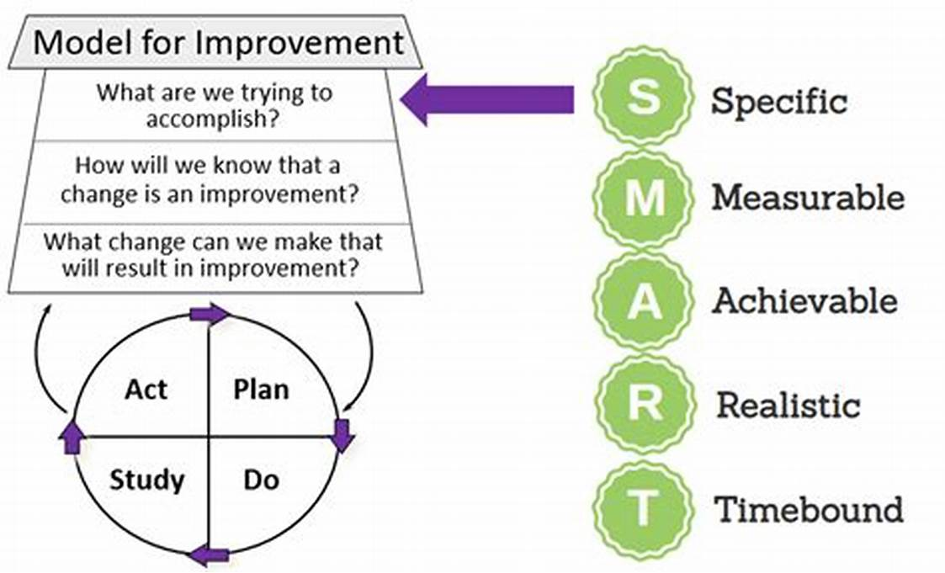

Figure 4 SMART model, (Doran, 1981).

1. **Time Management Improvement:**
   * **Specific**: Implement a time-blocking strategy, allocating specific periods during the day for focused work on high-priority tasks.
   * **Measurable**: Use a time-tracking application to monitor time spent on various tasks, aiming for a 20% reduction in time spent on low-priority activities within the next four weeks.
   * **Achievable**: Begin each day with a 15-minute planning session to prioritize tasks based on importance and deadlines (Macan, 1994).
   * **Relevant**: Enhancing time management is crucial for improving project delivery and reducing work-related stress.
   * **Time-bound**: Review progress in four weeks to assess the effectiveness of the time-blocking strategy and make necessary adjustments (Eilam & Aharon, 2003).
2. **Delegation Improvement:**
   * **Specific**: Identify at least two tasks per week that can be delegated to team members.
   * **Measurable**: Track the frequency and outcomes of delegation, aiming for a 50% increase in delegation over two months.
   * **Achievable**: Provide clear instructions and conduct weekly check-ins to ensure tasks are being completed effectively (Hackman & Wageman, 2005).
   * **Relevant**: Effective delegation will allow more focus on strategic tasks and promote team development.
   * **Time-bound**: Evaluate the success of this approach after two months and adjust the delegation strategy as needed (Burke et al., 2006).

**Enhancing Personal Brand:** Improving these areas will significantly enhance my brand as a project manager. Strong time management skills are essential for reliability and efficiency, key attributes in project management roles (Kerzner, 2017). Similarly, effective delegation is a hallmark of leadership, showing the ability to manage resources and empower others—traits that are crucial for career advancement (Turner & Müller, 2005). By making these improvements, I will be better positioned to lead projects successfully and build a reputation as a competent and strategic leader. Strengthening these skills will significantly enhance my brand as a Project Manager in the technology industry, a role that demands high levels of efficiency and leadership.

## Conclusion

**Summary of Key Points:** This report has explored my effectiveness by reflecting on my skill set, assessing my habits and behaviors, and developing a short-term improvement plan. Through reflection, I identified strengths in communication and proactivity but recognized weaknesses in time management and delegation. The Covey Self-Assessment further highlighted these areas, linking them directly to my career in project management.

**Concluding Statement:** Personal effectiveness is essential for achieving professional success, particularly in leadership roles that require strategic thinking and effective management. By focusing on improving time management and delegation, I am actively enhancing my capabilities as a project manager. These ongoing efforts will not only support my career progression but also contribute to the success of the teams and projects I manage, ensuring sustained professional growth and development.

# References:

Bateman, T. S., & Crant, J. M. (1993). The proactive component of organizational behavior: A measure and correlates. *Journal of Organizational Behavior*, 14(2), 103-118.

Britton, B. K., & Tesser, A. (1991). Effects of time-management practices on college grades. *Journal of Educational Psychology*, 83(3), 405-410.

Brown, K. W., & Ryan, R. M. (2003). The benefits of being present: Mindfulness and its role in psychological well-being. *Journal of Personality and Social Psychology*, 84(4), 822-848.

Burke, C. S., Stagl, K. C., Salas, E., Pierce, L., & Kendall, D. (2006). Understanding team adaptation: A conceptual analysis and model. *Journal of Applied Psychology*, 91(6), 1189-1207.

Claessens, B. J. C., van Eerde, W., Rutte, C. G., & Roe, R. A. (2007). A review of the time management literature. *Personnel Review*, 36(2), 255-276.

Covey, S. R. (1989). *The 7 Habits of Highly Effective People: Powerful Lessons in Personal Change*. Free Press.

Crant, J. M. (2000). Proactive behavior in organizations. *Journal of Management*, 26(3), 435-462.

Doran, G. T. (1981). There’s a SMART way to write management’s goals and objectives. *Management Review*, 70(11), 35-36.

Eilam, B., & Aharon, I. (2003). Students’ planning in the process of self-regulated learning. *Contemporary Educational Psychology*, 28(3), 304-334.

Hackman, J. R., & Wageman, R. (2005). A theory of team coaching. *Academy of Management Review*, 30(2), 269-287.

Hargie, O. (2010). *Skilled Interpersonal Communication: Research, Theory, and Practice*. Routledge.

Kerzner, H. (2017). *Project Management: A Systems Approach to Planning, Scheduling, and Controlling*. John Wiley & Sons.

Macan, T. H. (1994). Time management: Test of a process model. *Journal of Applied Psychology*, 79(3), 381-391.

Parker, S. K., Bindl, U. K., & Strauss, K. (2010). Making things happen: A model of proactive motivation. *Journal of Management*, 36(4), 827-856.

Schon, D. A. (1983). *The Reflective Practitioner: How Professionals Think in Action*. Basic Books.

Turner, J. R., & Müller, R. (2005). The project manager’s leadership style as a success factor on projects: A literature review. *Project Management Journal*, 36(2), 49-61.

Van der Meer, J., Jansen, E., & Torenbeek, M. (2010). “It’s almost a mindset that teachers need to change”: First-year students need to be inducted into time management. *Studies in Higher Education*, 35(7), 777-791.

Weldy, T. G. (2009). Learning organization and transfer: Strategies for improving performance. *The Learning Organization*, 16(1), 58-68.

Yukl, G., & Mahsud, R. (2010). Why flexible and adaptive leadership is essential. *Consulting Psychology Journal: Practice and Research*, 62(2), 81-93.

DeRue, D. S., Ashford, S. J., & Myers, C. G. (2012). Learning agility: In search of conceptual clarity and theoretical grounding. *Industrial and Organizational Psychology*, 5(3), 258-279.

Eisenhardt, K. M., & Martin, J. A. (2000). Dynamic capabilities: What are they? *Strategic Management Journal*, 21(10-11), 1105-1121.

Gustafsson, K., & Salo, I. (2012). Burnout and engagement in university students–A narrative review. *Journal of Higher Education*, 3(1), 42-50.

Häusser, J. A., Mojzisch, A., & Schulz-Hardt, S. (2011). Ten years on A review of recent research on the Job Demand–Control (-Support) model and psychological well-being. *Work & Stress*, 25(1), 1-35.

Locke, E. A., & Latham, G. P. (2002). Building a practically useful theory of goal setting and task motivation: A 35-year odyssey. *American Psychologist*, 57(9), 705-717.

Maslach, C., & Leiter, M. P. (2016). Burnout in context: A review and future research agenda. *Annual Review of Psychology*, 52(1), 397-422.

Sonnentag, S., & Fritz, C. (2007). The recovery experience questionnaire: Development and validation of a measure for assessing recuperation and unwinding from work. *Journal of Occupational Health Psychology*, 12(3), 204-221.